A Living Tradition CIC
Gateshead Roma Kavárna Project
Report for January to March 2021
Firstly, a huge heartfelt thanks to the National Lottery and Awards for All for all their generous support again this year. It is much appreciated.
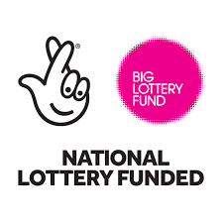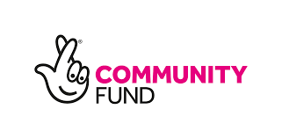
We have continued to help the Roma Community in Gateshead during the very difficult months of the Lockdown from January to March 2021.
We have continued to provide people with food from the Fareshare Foodbank.
We have been engaged in translating to help eastern European Roma through the often difficult EUSS process. It is very important that the families get through this process and we have also liaised with a local primary school in Gateshead to help to get the message to parents about how important it is. We have also continued to work to help members of the Roma community to understand what they need to do for the EUSS process. And help them to get help from the Children’s Society if needed
We have also helped people from this very marginalised community to understand what to do regarding the census, which took place in March. We were able to hold a Zoom meeting about the Census in March.
We have also been encouraging people to take the Covid-19 vaccine when they have the opportunity to do so, including a Zoom meeting with a doctor and a nurse in March, a meeting with clients which had a very good outcome.
We have been passing information on to the community about scams, which are going round at the moment. We have been able to warn them about what the scammers are trying to do and help them to know what the warning signs are that somebody is trying to scam them.
We have also been fielding enquiries about issues such as Universal Credit as we usually do.
Many thanks to the doctor and nurse who helped us, and to Fareshare, Kelvingrove Primary School, Citizens Advice Gateshead, the Children’s Society and all our other colleagues and supporters.
Peter Sagar, Company Secretary, A Living Tradition CIC, and Irma and Zaneta Karchnakova, interpreters and workers, April 2021

